26 Editors - File browser
File Browser 3
Header 4
Navigation 4
Previous Folder 4
Next Folder 4
Parent File 4
Refresh 4
New Folder 4
File path 4
Search 4
Display Options 5
Display As 5
Vertical List 5
Horizontal List 5
Thumbnails 5
Size 5
Date 5
Recursion 6
Sort by 6
Reverse Sorting 6
Filter 6
Filter 6
Folders, etc. 6
Show Hidden 6
Toggle Region 6
Tool Shelf 7
System Panel 7
System Bookmarks 7
Favourites 7
Recent 7
Sidebar 7
Load UI 8
Trusted Source 8
File dialog 8
Click navigation. 8
Double Click to load 8
Double click to save 8
Select and load more than one file 8
Box select 8
Renaming 9
File Name 9
Open / Save 9
Cancel 9
Footer 9
View Menu 9
Tool Shelf 9
Display Size 9
Recursion 9
Area Menu 10
Horizontal Split 10
Vertical Split 10
Duplicate Area into new Window 10
Toggle Maximize Area 10
Toggle Fullscreen Area 10
Select menu 10
Box Select 10
Inverse 10
None 10
All 10

File Browser
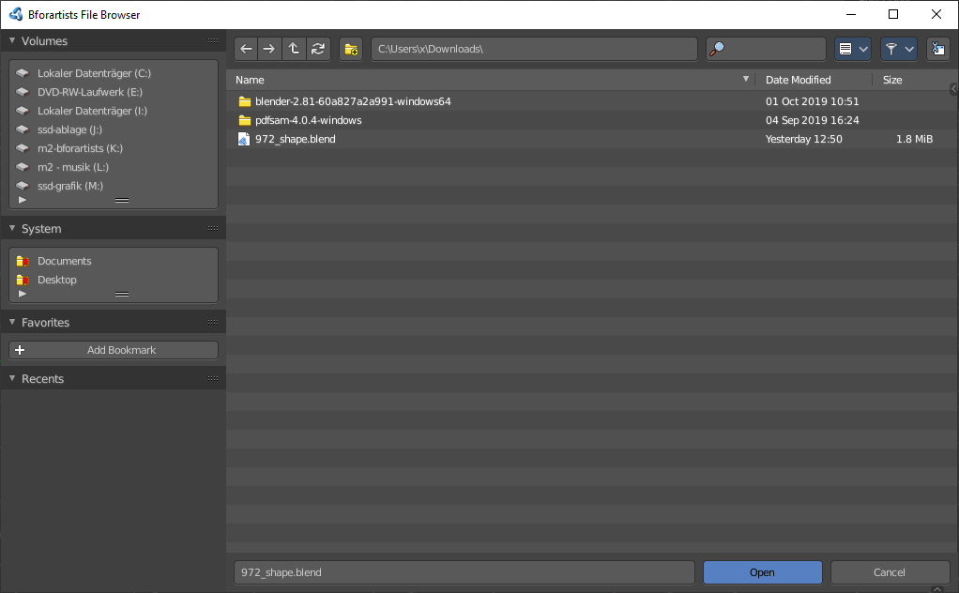
The file browser is a explorer dialog that allows you to browse for locations and files, and allows you to load and save them.
The file browser has multiple uses. While its often used for save/load, it can be kept open for other uses too.
In the file browser you can:
- Opening and Saving Blend files.
- Import/Export other file formats.
- Picking new locations for existing file-paths (images, video’s, fonts... etc).
- Browsing inside other .blend files, when using Append and Link.
You can also keep the file selector open, as with any other window type. In this case the buttons to load files is removed. The main purpose of this is to be able to drag media files.
- Images into the Video Sequence Editor (to set background or apply as material textures).
- Media files into the Video Sequence Editor.

Header

There are several tools in the header to find. The range goes from navigation elements across filters up to display options.

Navigation
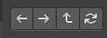
Here you can navigate in the folder hierarchy.

Previous Folder
Navigate to the previous folder.

Next Folder
Navigate to the next folder.

Parent File
Go upwards in the hierarchy.

Refresh
Refresh the file list.


New Folder
Creates a new folder.

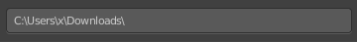
File path
The current directory.

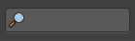
Search
Name Filter. Here you can search for specific files and folders.

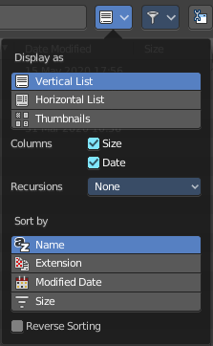
Display Options

Display As
There are three methods to display the content of the folders.

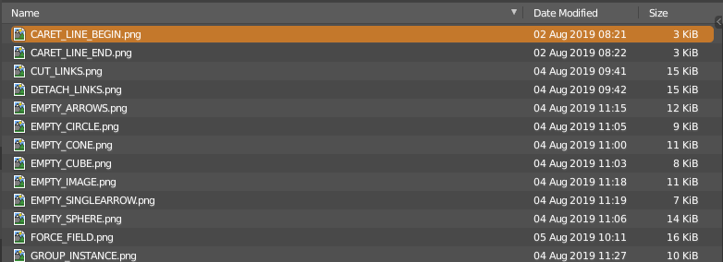
Vertical List
Displays the content of the file browser as a vertical list.

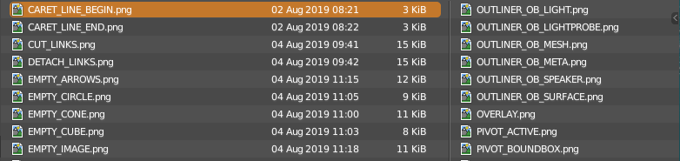
Horizontal List
Displays the content of the file browser as a horizontal list.

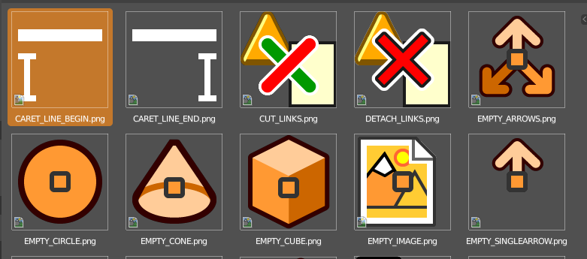
Thumbnails
Displays the content of the file browser as thumbnails. This is especially of use for images or blend files with thumbnail preview.

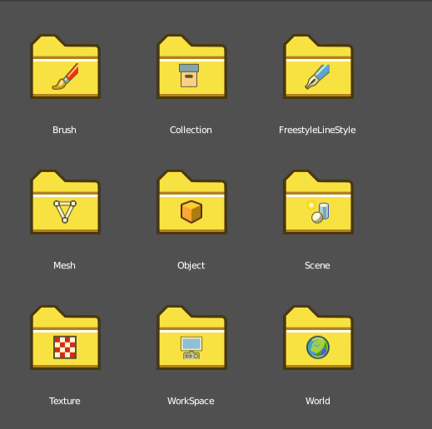
When you link or append from a blend file then the thumbnails also shows folders with icons for the different content of the library blendfile.

Size
Display the size of the files.

Date
Display the creation date of the files.

Recursion
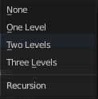
Here you can adjust how deep the explorer should dig. Normally it just lists the content of the currently selected directory. But it is also possible to list the content of the folders three levels lower.
The recursion direction is always downwards. Default is None.

Sort by
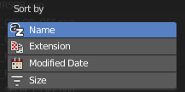
Sort the files by chosen method. The methods are self explaining.

Reverse Sorting
Reverts the sorting direction.

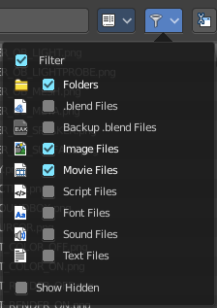
Filter

Filter
Enable the filtering.

Folders, etc.
The different file types that should be filtered. What is ticked here and what file types shows depends of what file browser you call. If you want to load a blend file. Or a FBX file from the File menu in the header. Or a image in the UV Editor for example.

Show Hidden
Shows hidden Dot files.
This is a Unix feature. Unix systems like Linux or Mac hides files from file browsers and explorers by having a dot before the file. A good example is the .htaccess file at servers. Show hidden Dot Files makes such files visible to the file browser.

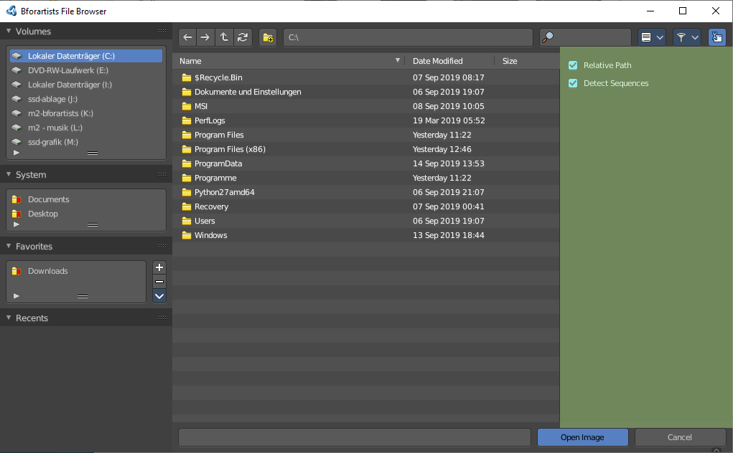
Toggle Region
Toggles the sidebar at the right. The sidebar contains various im and export settings for the single file types.

Tool Shelf

The Tool Shelf at the left provides you with some panels for quick access to files and bookmarks.

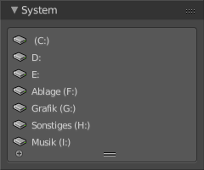
System Panel
Lists your drives.

System Bookmarks
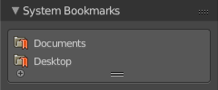
Lists some system libraries.

Favourites
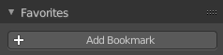
Here you can add your own bookmarks. A direct bookmark towards the Downloads folder for example.
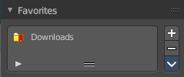

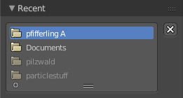
Recent
A list of the recent accessed folders.
Greyed out folders are not longer existing directories. There is unfortunately no way to remove them from within Bforartists. You would need to do this manually in the History text files in the settings folder.
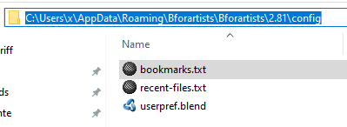
Under Windows this is the bookmarks.txt file in the Appdata folder.

Sidebar
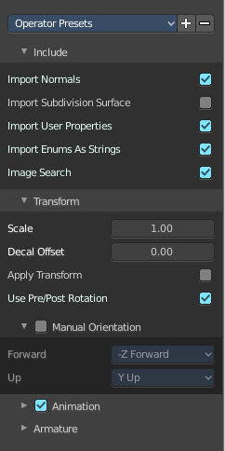

At the right side you will find the special Import or Export settings for the current file format. For a Blend file you will just see two entries. For file formats like FBX you wil find plenty of settings.
At the right you see the import dialog for FBX.

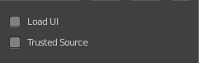
As an example, and to explain the two settings for loading a blend file:

Load UI
Bforartists comes with the feature *Load UI* unticked. This means the Bforartists UI will not change when you load a scene. Here you can temporary enable to load the scene with the layout and UI arrangement in which the scene was saved.

Trusted Source
With Load UI you can also load script files, which can execute. This is a potential security risk when the file comes from an unknown source.

File dialog

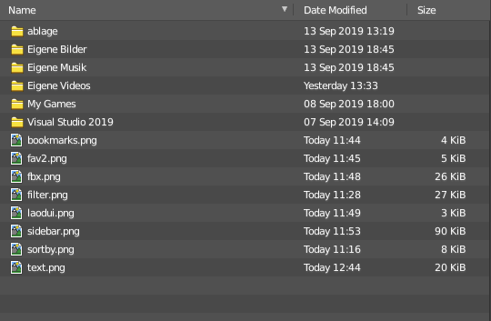
The file dialog is the actual place where your files and directories gets listed.

Click navigation.
Double clicking at a folder enters the folder. To go upwards in the hierarchy see Parent File button in the header.

Double Click to load
Double clicking at a file loads the chosen file when you are in a load dialog. The file dialog will then close.

Double click to save
Double clicking at a file overwrites the chosen file when you are in a save dialog.
The file dialog will then close.

Select and load more than one file
Holding down shift allows you to select and to load more than one file.

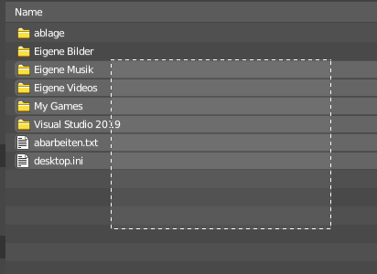
Box select
You can drag a box around the files by simply left clicking and moving the mouse.

Renaming
You can rename files and folders from within this list. Holding down ctrl and clicking at a file enters the edit file name mode.

File Name
Here you can read the file that you want to load or to save.

Open / Save
Open or save the current file(s).

Cancel
Cancel the loading or save process and close the file browser.

Footer

Formerly the header. The footer is hidden by default. But contains some more functionality.
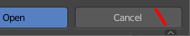
You can reveal the footer by clicking at the triangle button at the right.

And then you will see the footer bar. Which will reveral two menus. View and Select.

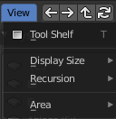
View Menu

Tool Shelf
Shows or hides the tool shelf at the left side

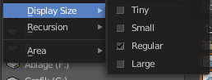
Display Size
Here you can set the display size of the file browser to four predefined sizes.

Recursion
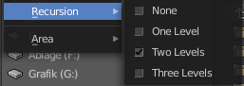
Recursion is a dropdown menu where you can adjust how deep the explorer should dig. Normally it just lists the content of the currently selected directory. But it is also possible to list the content of the folders three levels lower.
The recursion direction is always downwards. Default is None.

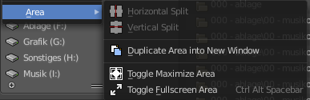
Area Menu
Area is a menu with window related settings.

Horizontal Split
Splits the editor horizontally into two editors.

Vertical Split
Splits the editor vertically into two editors.

Duplicate Area into new Window
Creates a floating window out of the current editor.

Toggle Maximize Area
Displays the editor maximized with menus.
To return to split view press hotkey Ctrl Up Arrow, or reuse the menu item in the View menu.

Toggle Fullscreen Area
Displays the editor maximized without menus.
To return from the full screen view press hotkey Alt F10, or use the little button that appears up right when you move the mouse in this corner.

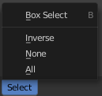
Select menu

Box Select
Allows you to box select files. Note that this is an old obsolete operator. You don't need to press the hotkey anymore for box select.

Inverse
Inverts the selection.

None
Select none.

All
Select all.

